NIM : 2602070244

Nama : Samuel

Final Web Programming Assignment

Notes : Maaf tidak rapi karena tidak ada desain, secara singkat fitur harusnya sudah oke, tetapi kodingan kurang rapi. Mohon maaf bila ada kesalahan, dan terima kasih. :D

1. User Authentication

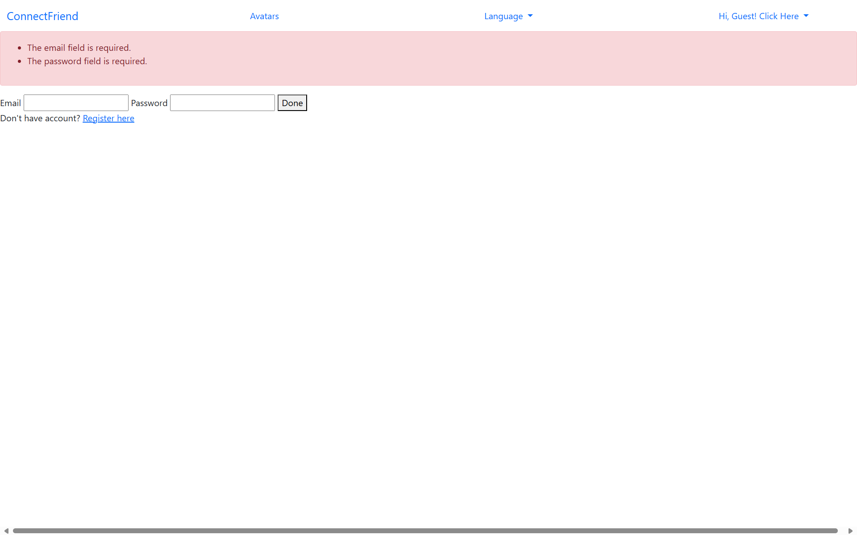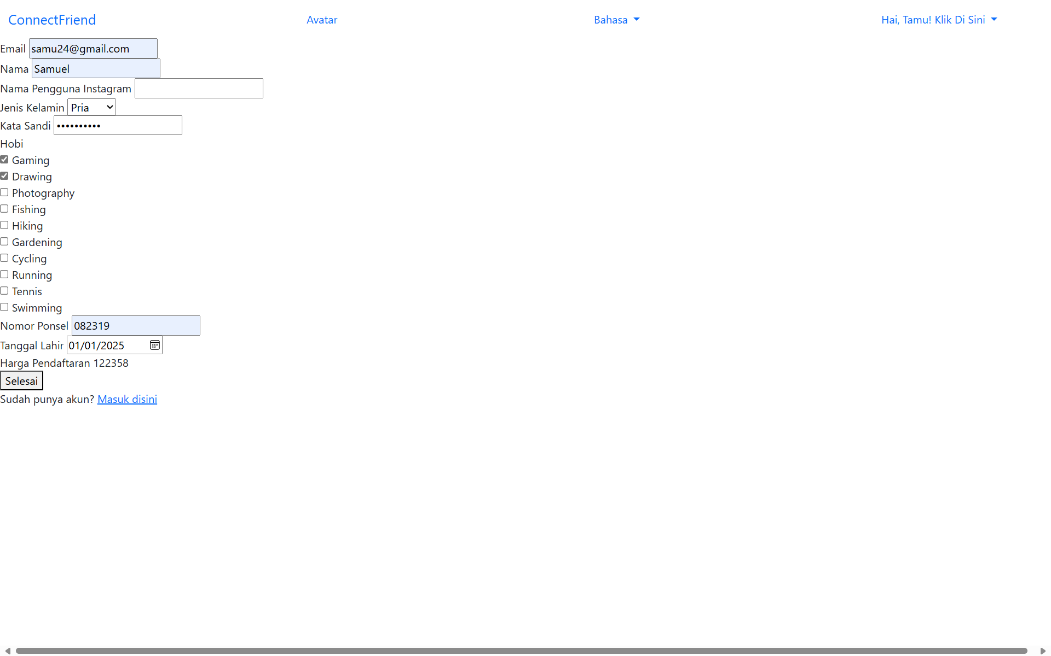

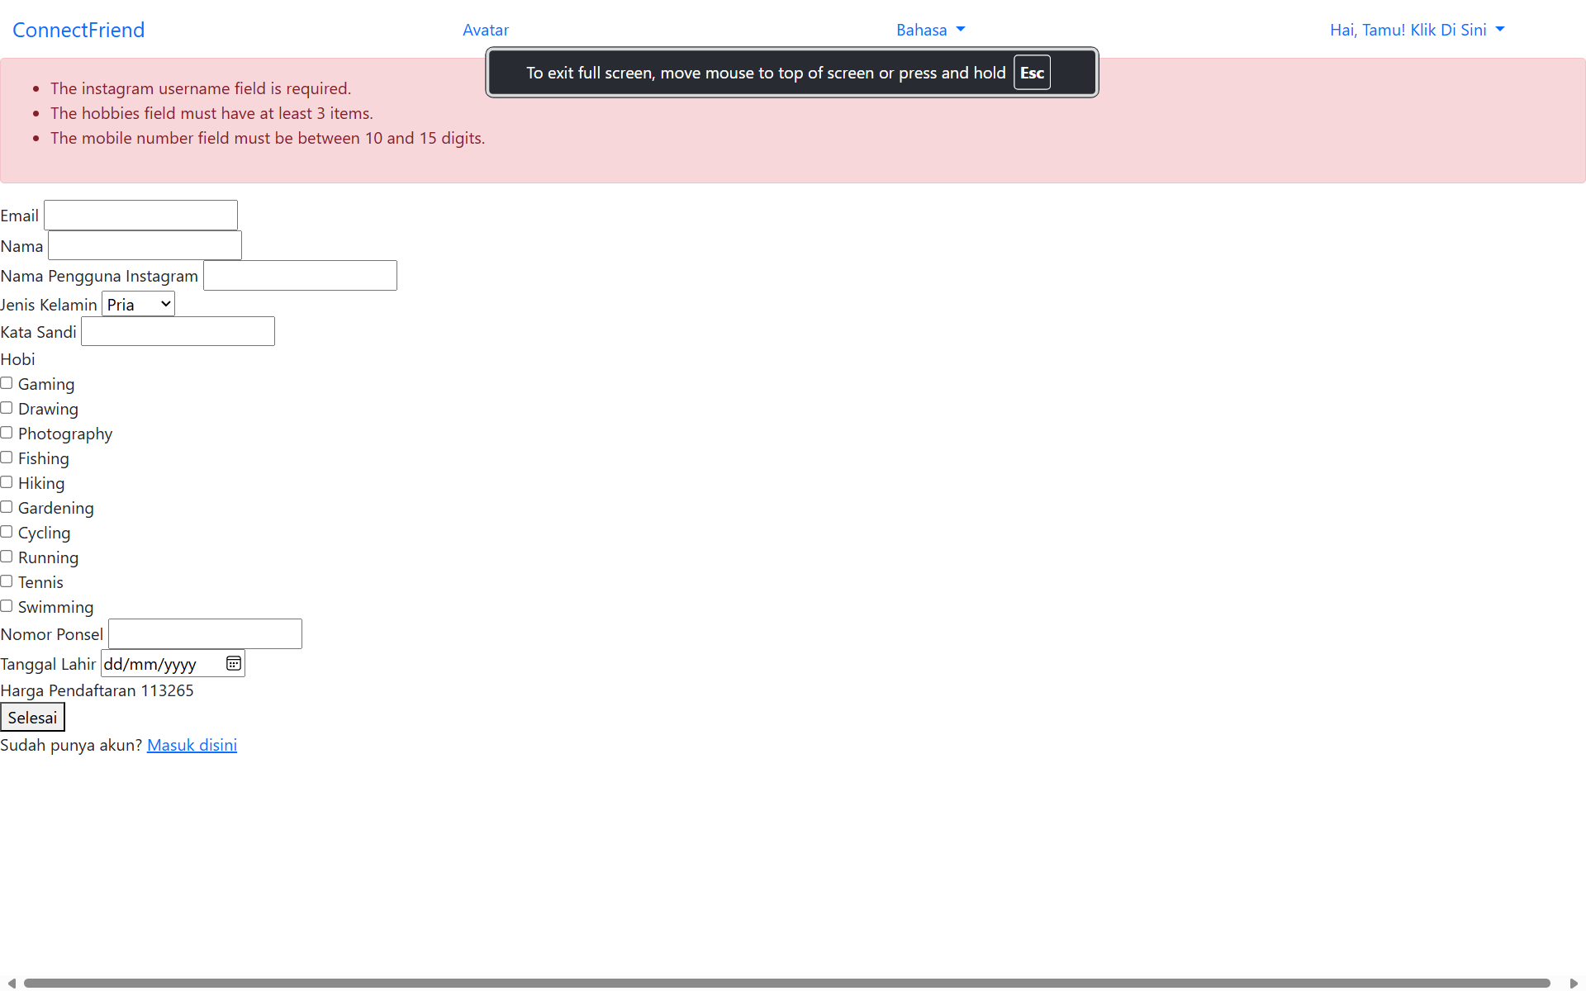

2. Payment

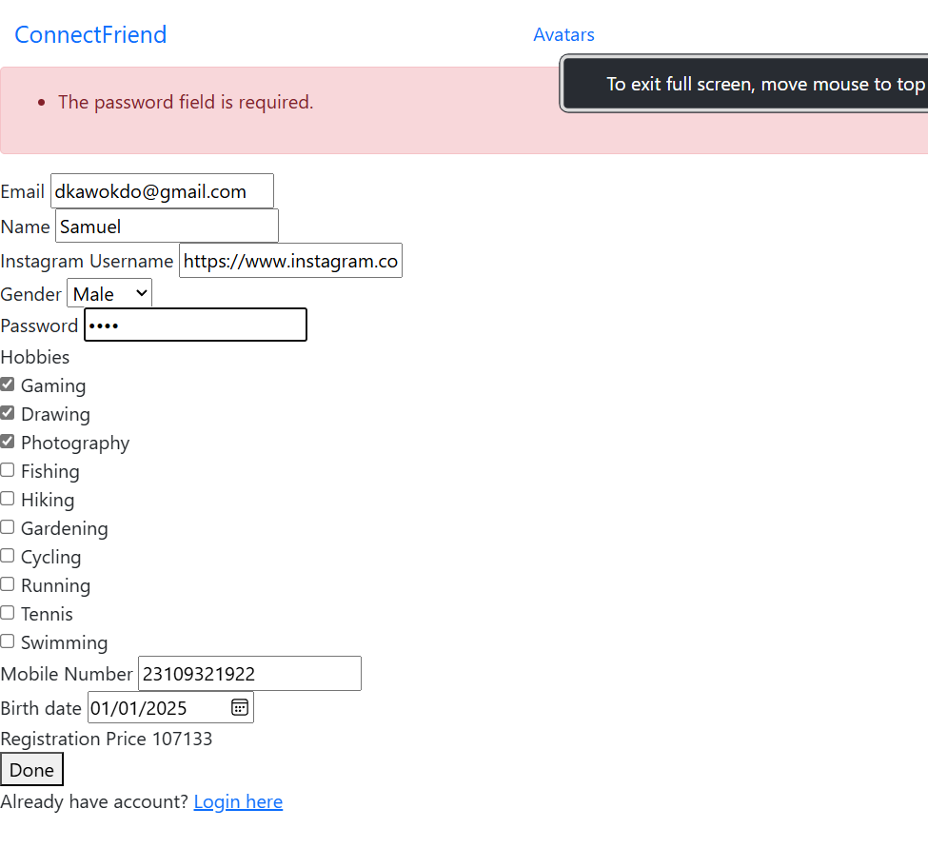

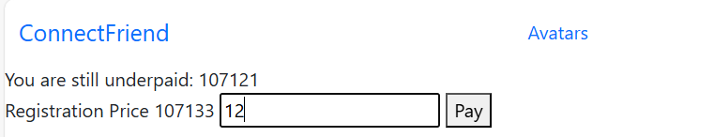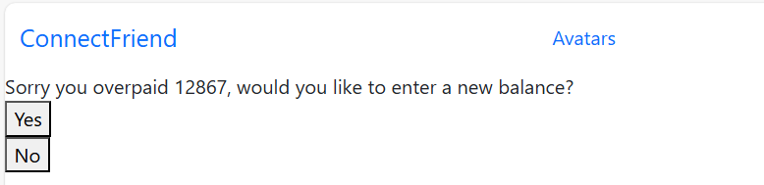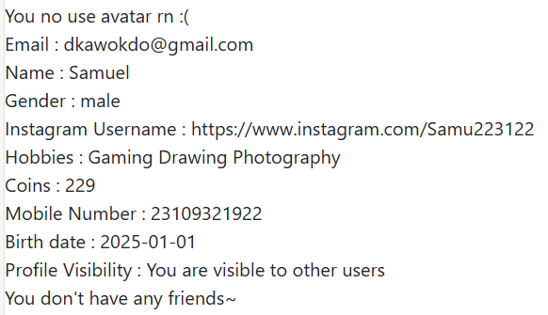

**Coins is 229 because coin cost = overpaid/100, 12900/100 = 129 extra coins.**

3. Friends

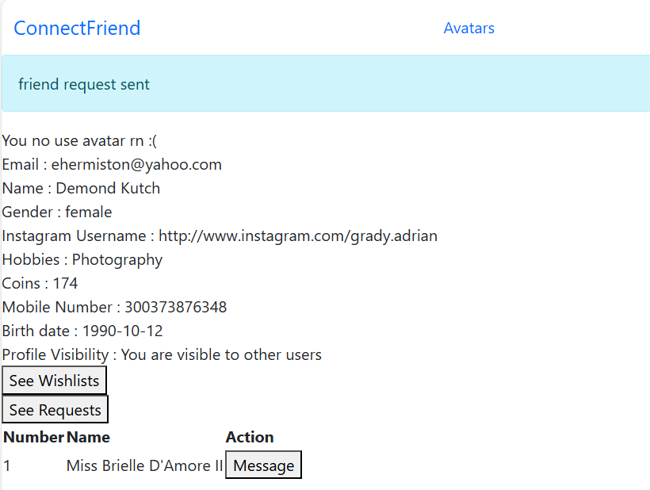

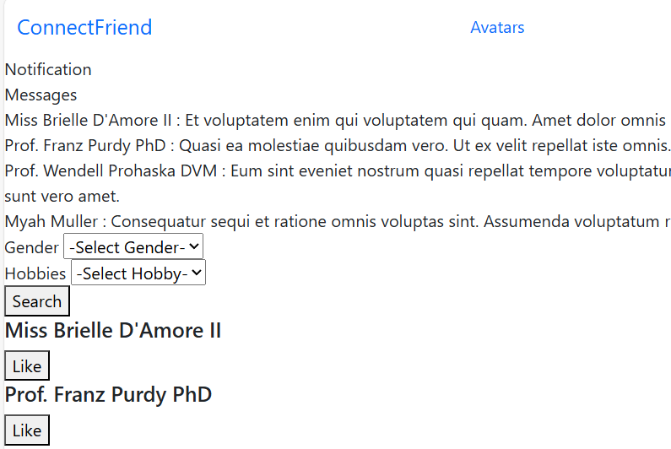

Like Prof Franz

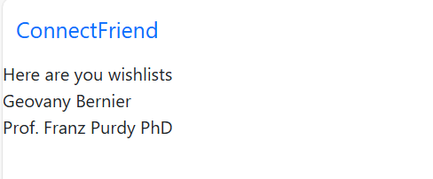

4. Messaging

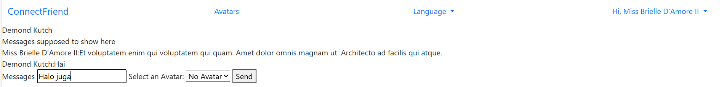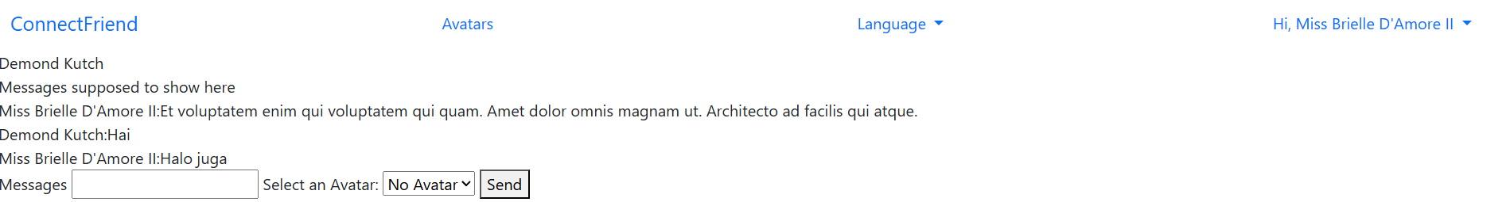

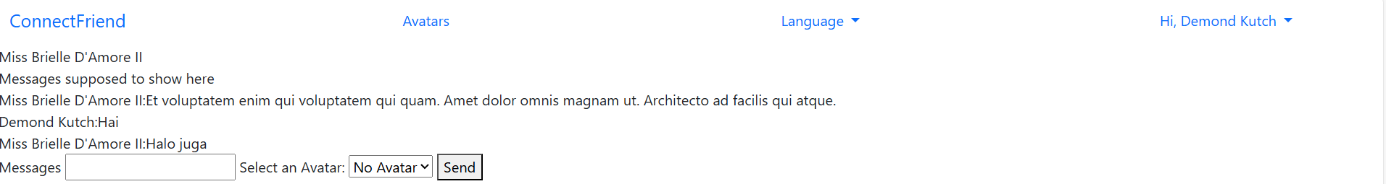

5, Searching & Filtering

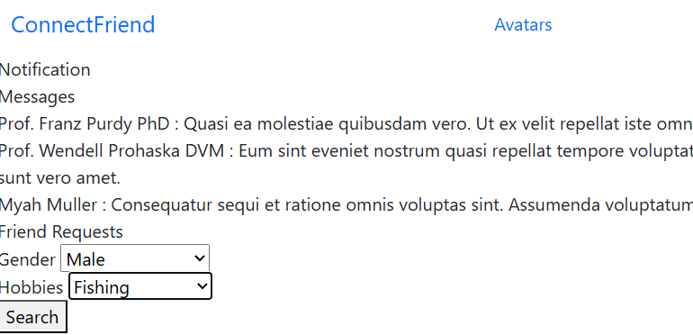

Prof Wendell’s ID is 4, Brandy Dach’s ID is 10, Fishing’s ID is 4

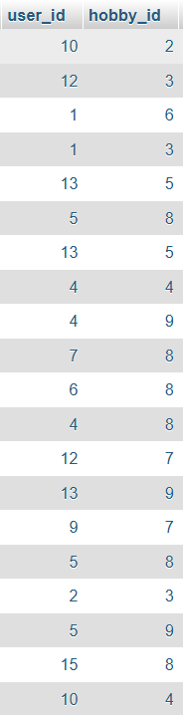



6. Notifications

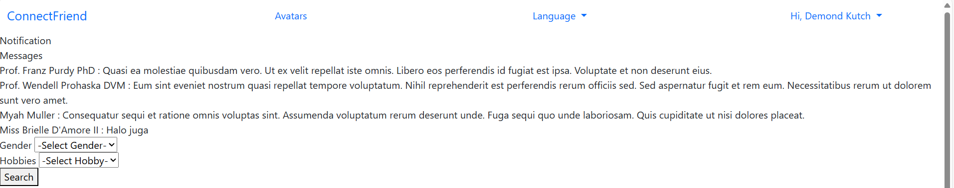

7. Buy Avatar

Profile before :

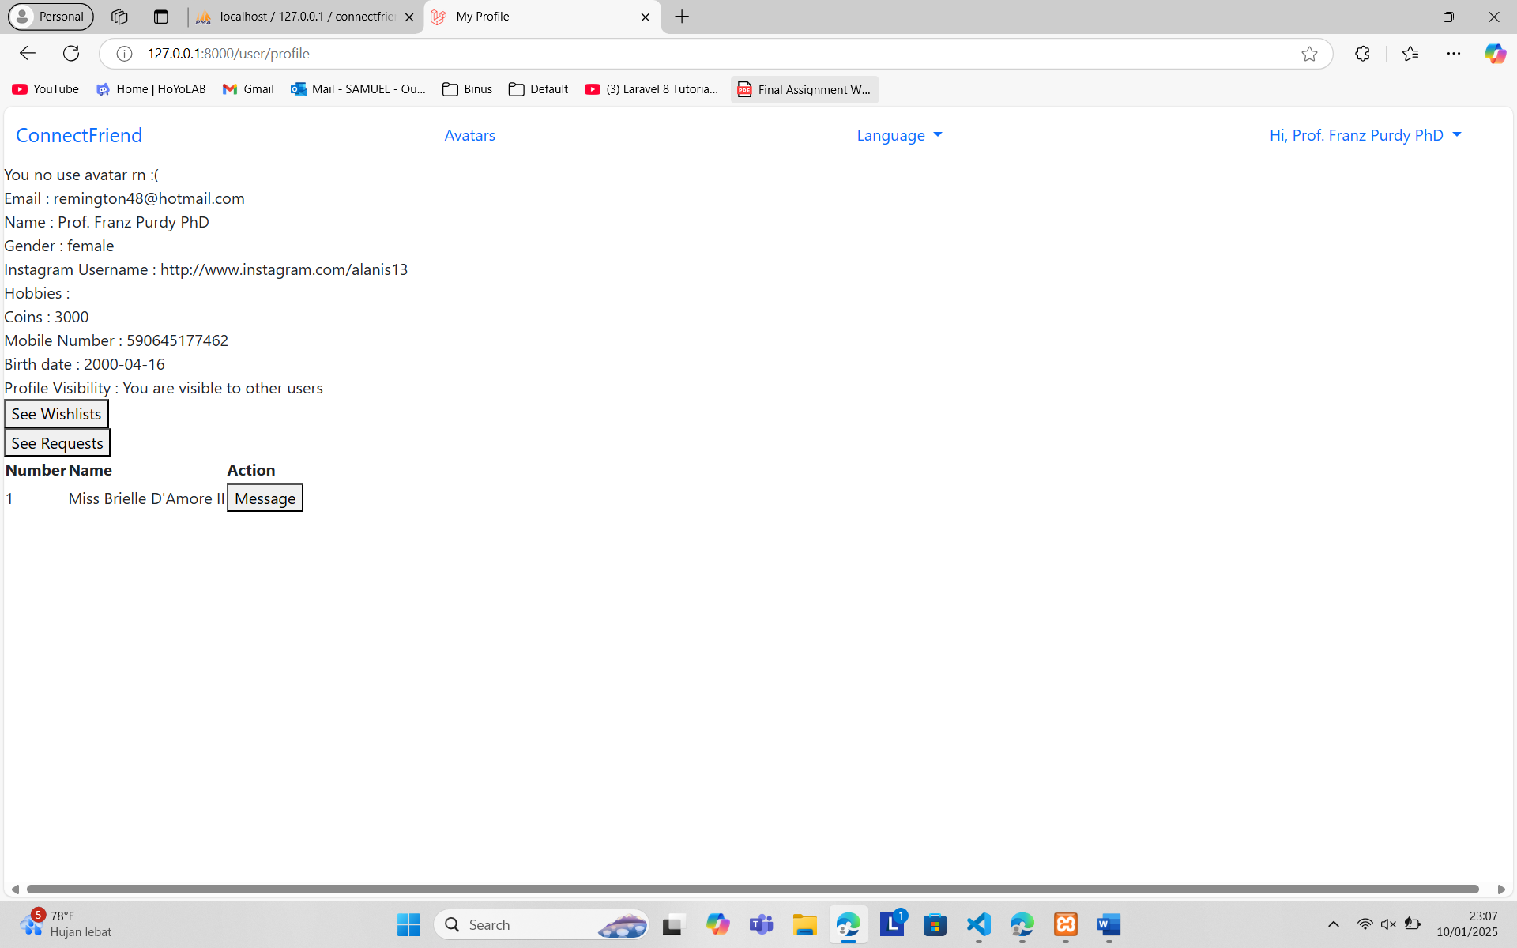

My Avatars before :

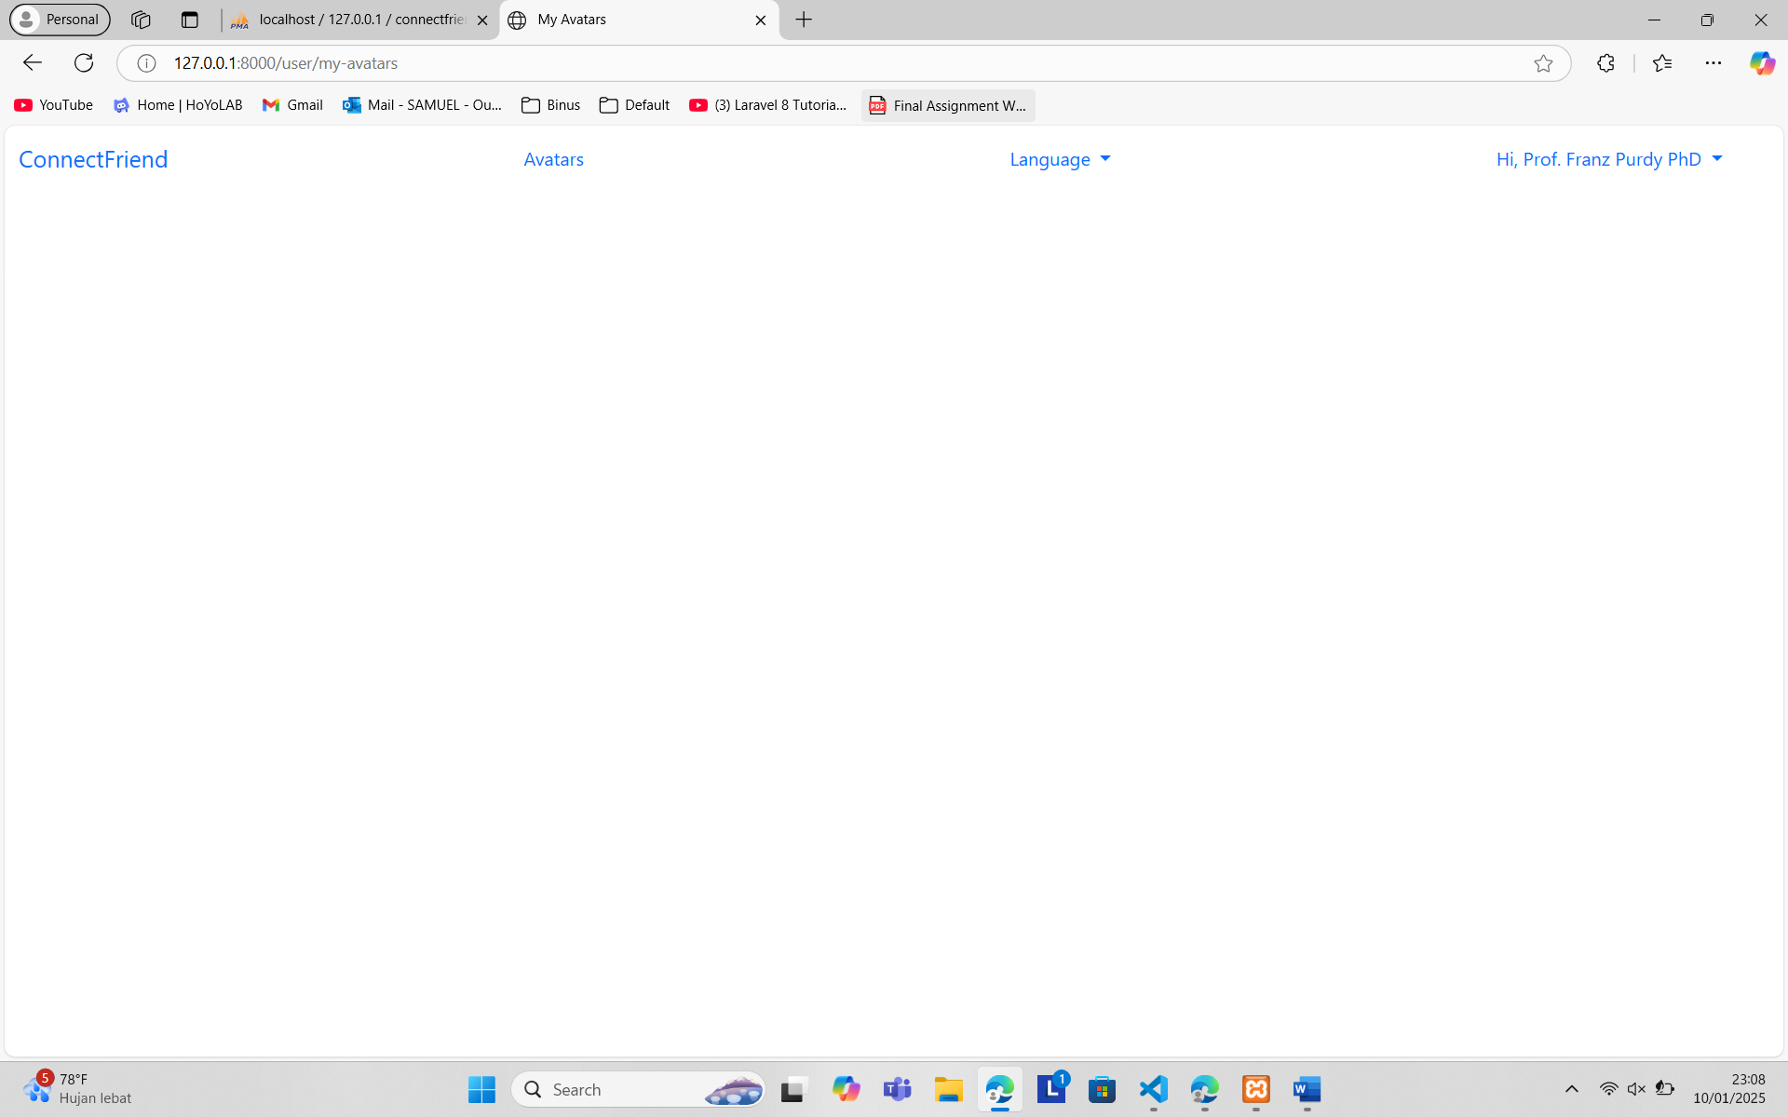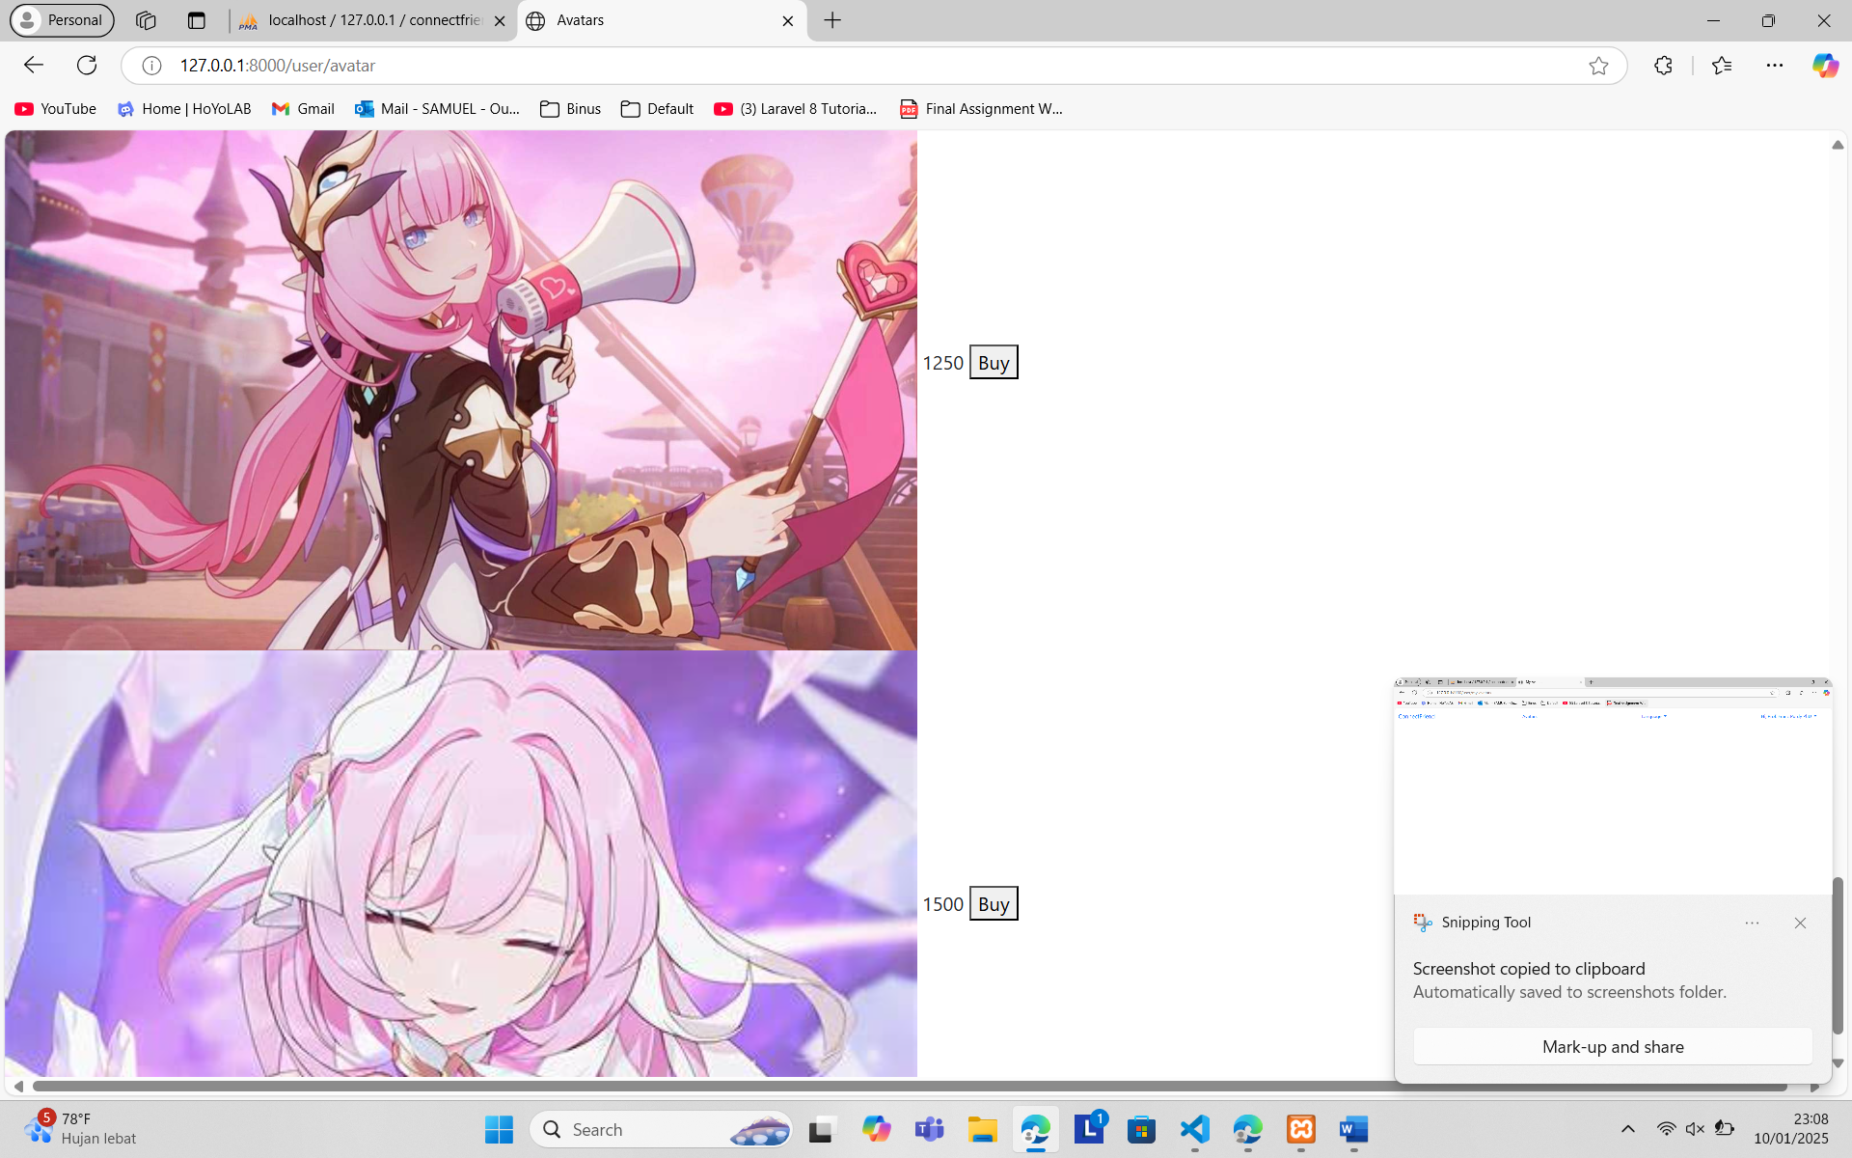

Profile after :

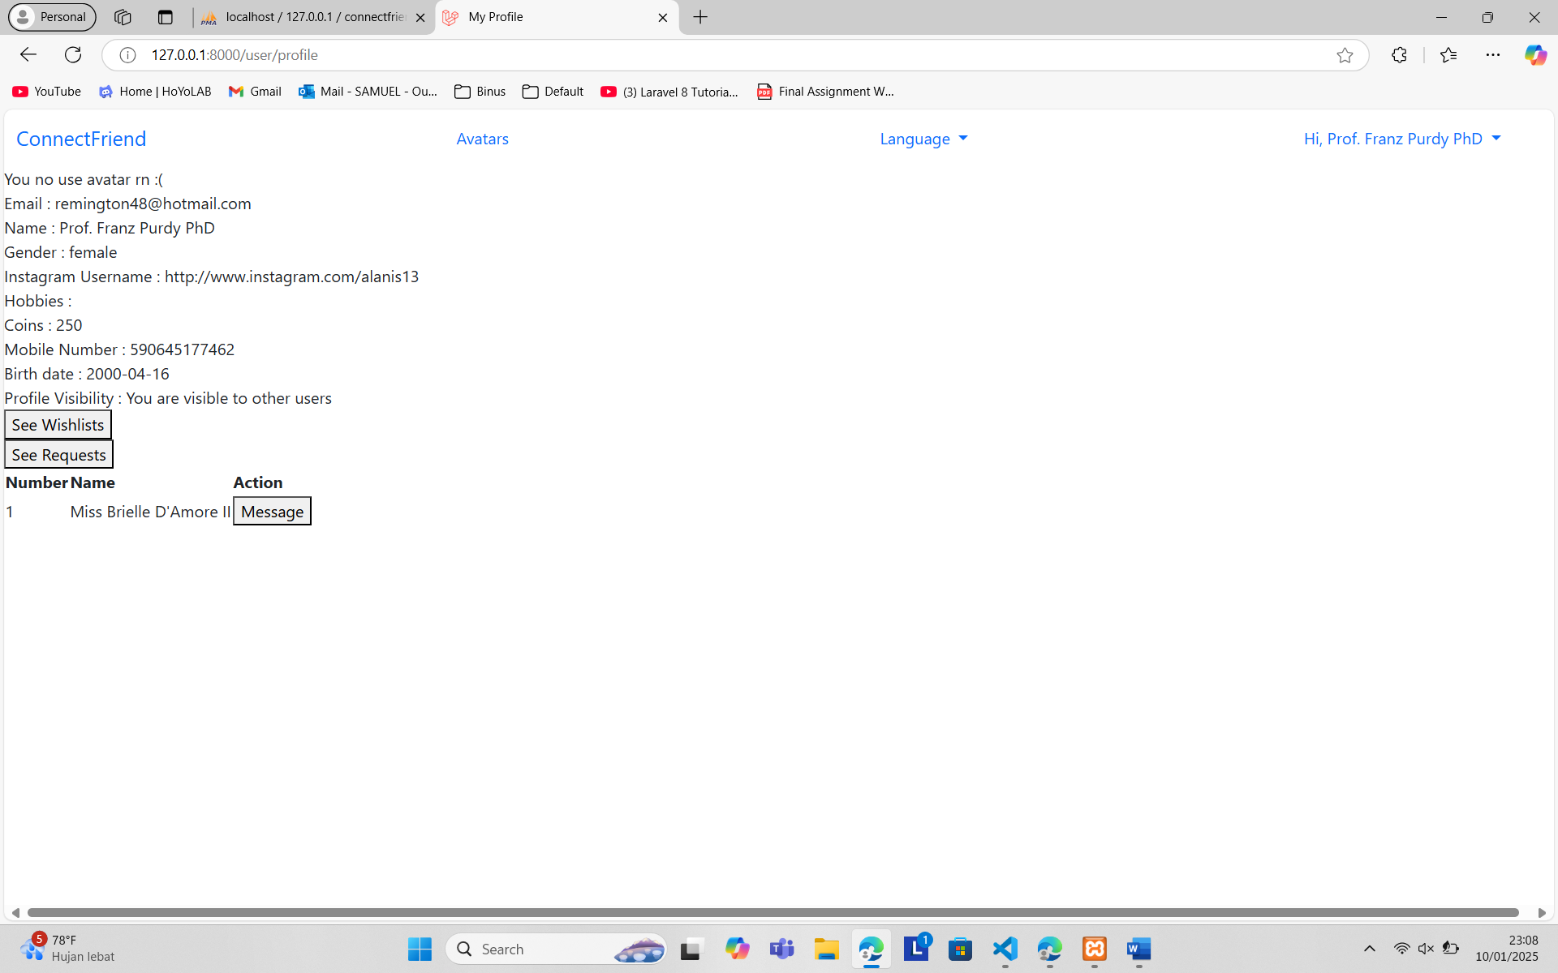

My Avatars after :

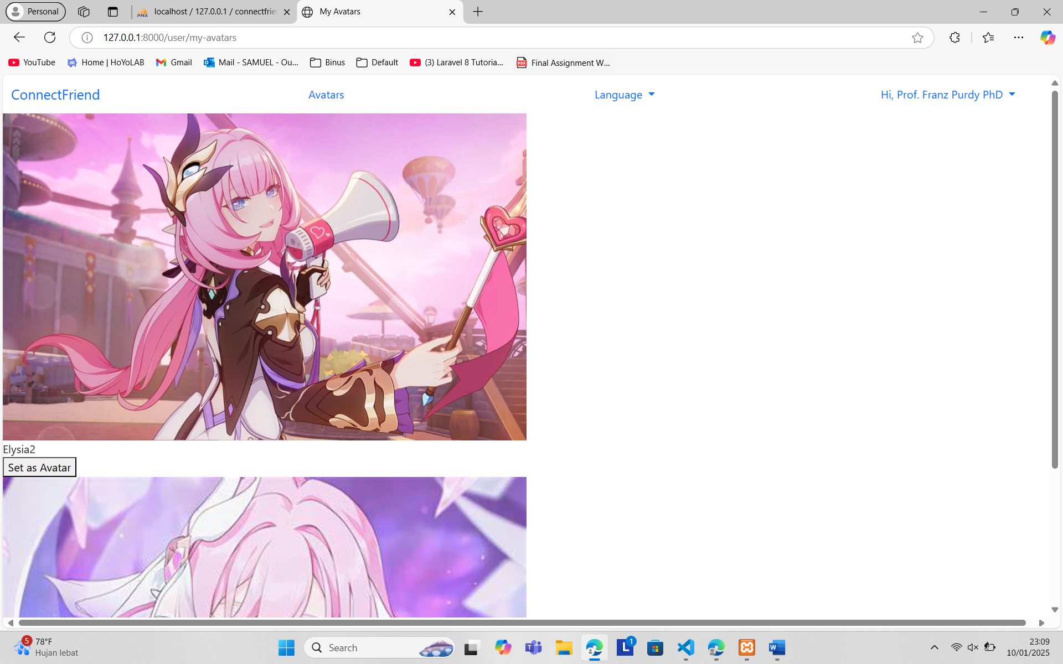

8. Topup Coins

Before :

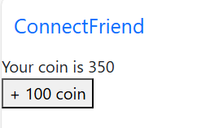

After :

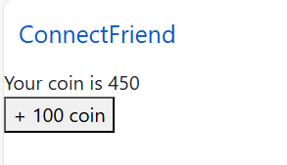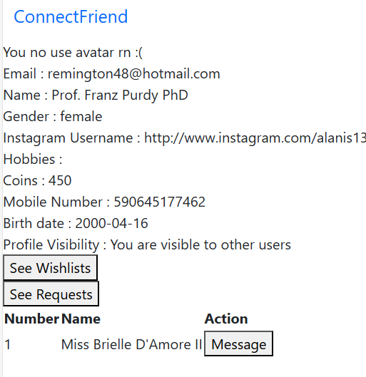

9. Advanced Chat

Prof Franz send avatar :

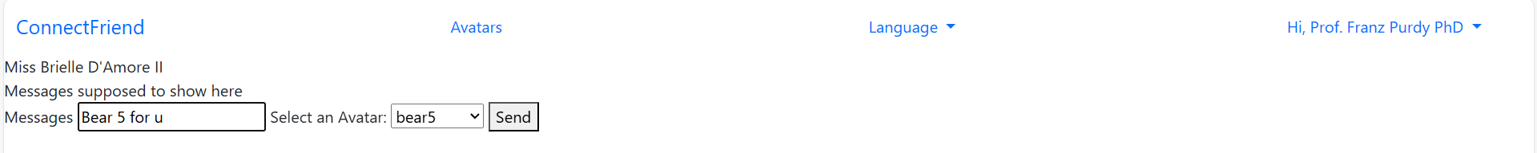

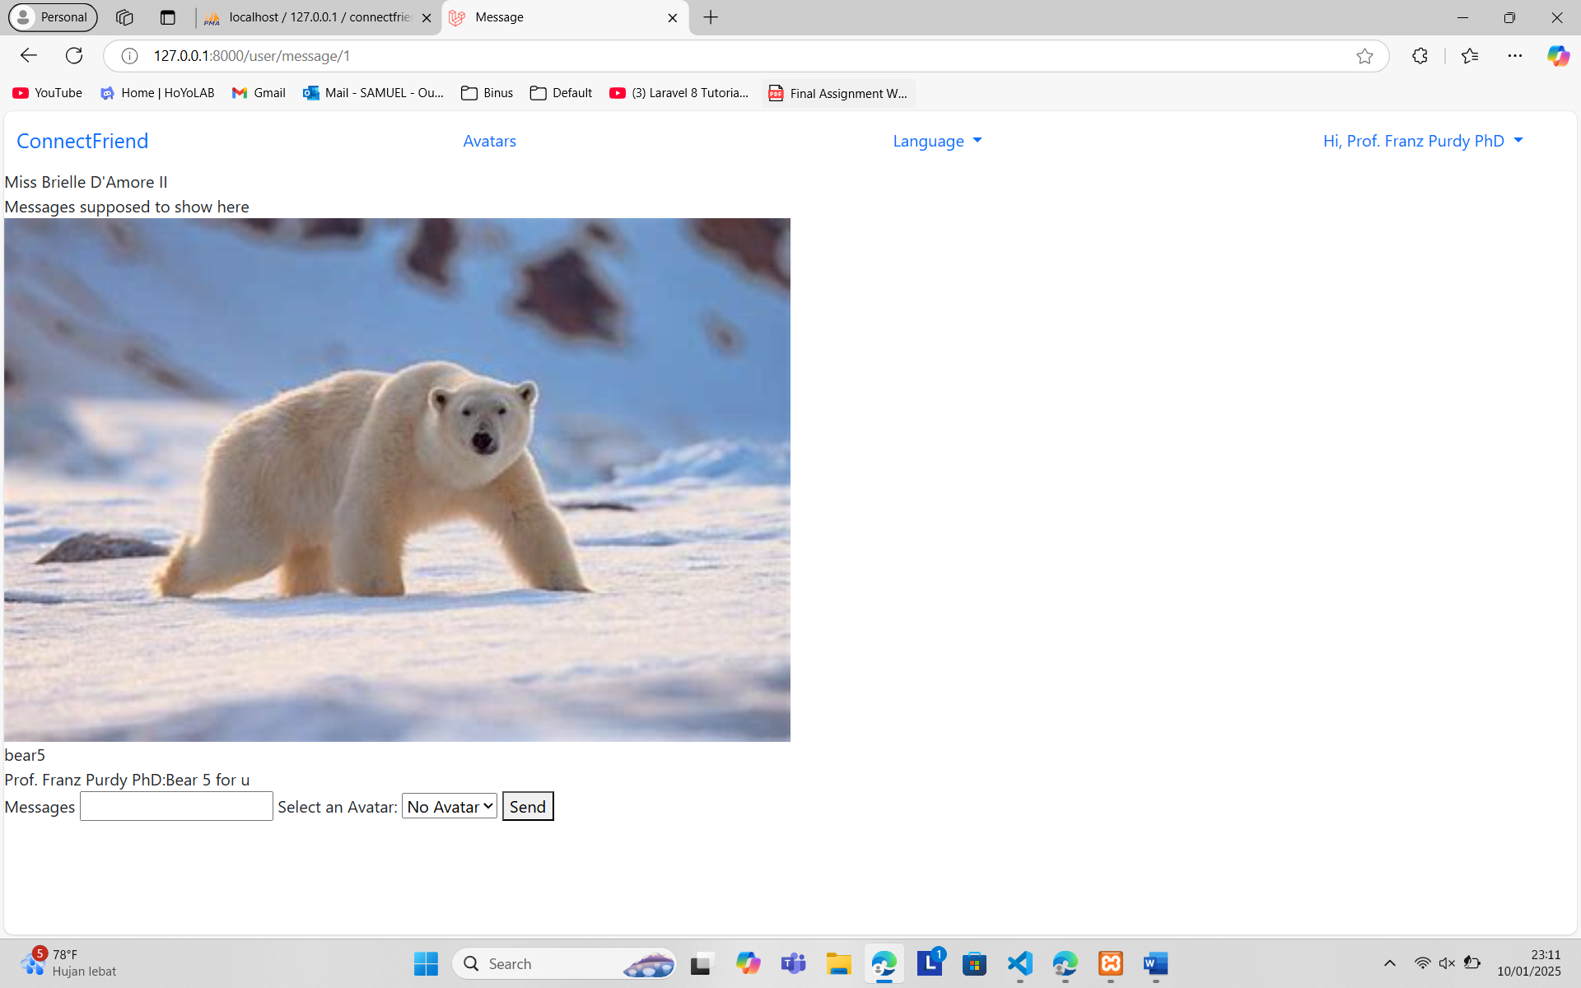

Miss Briell receive avatar :

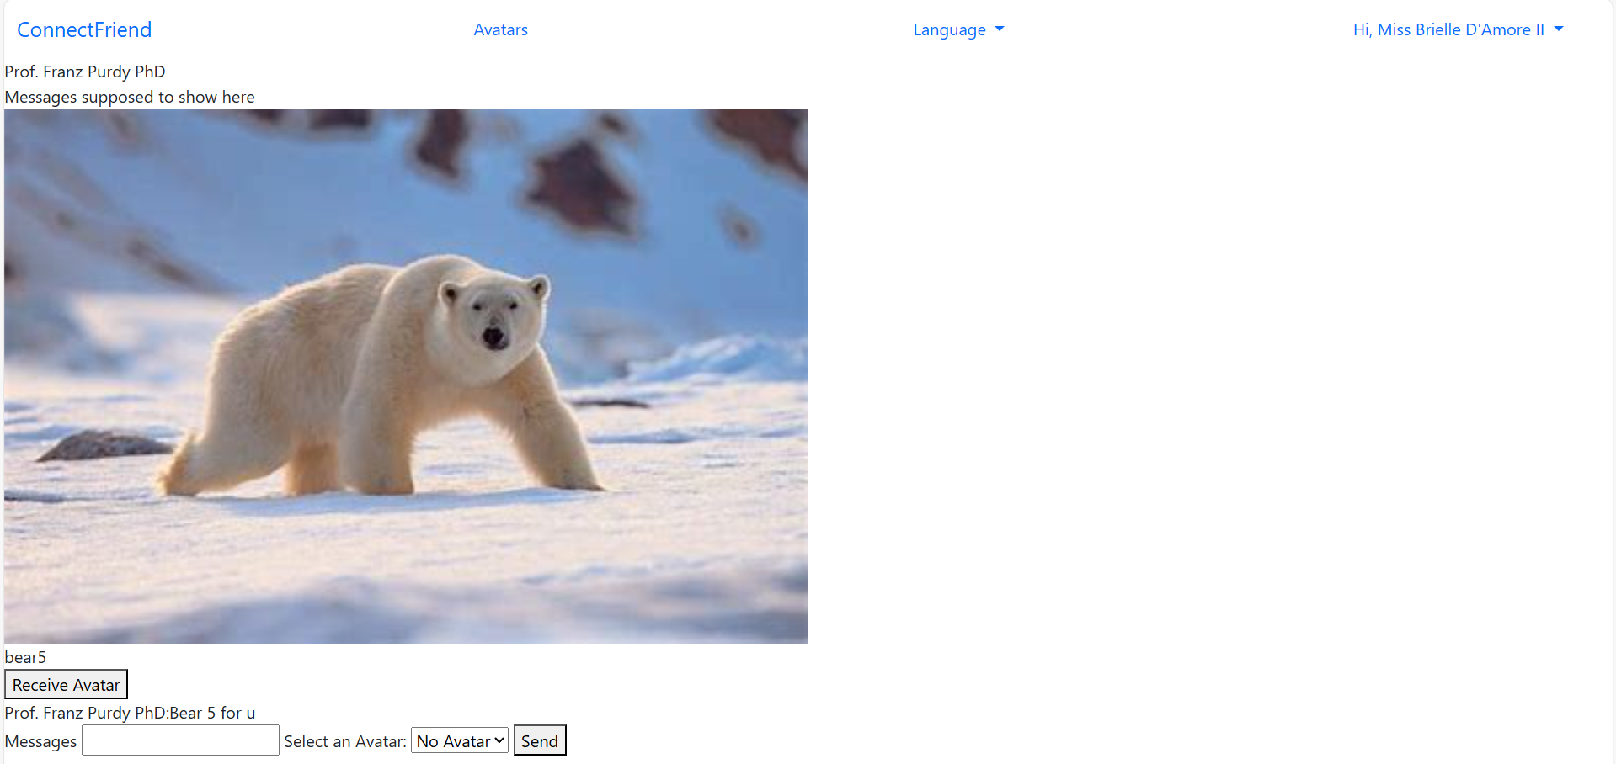

Miss Briell before receive :

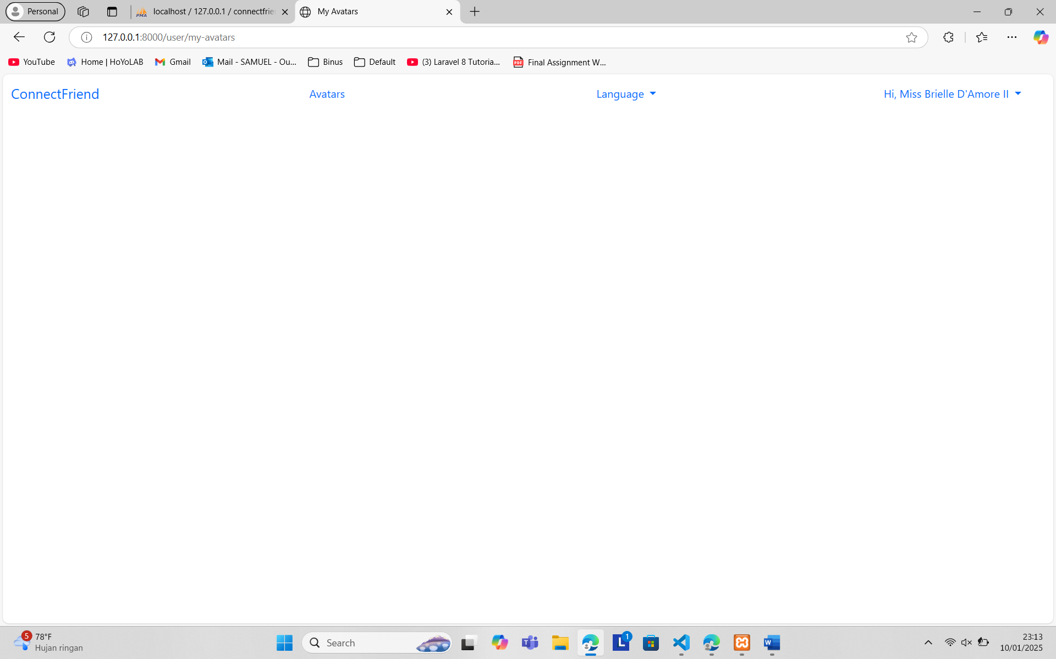

Miss Briell after receive :

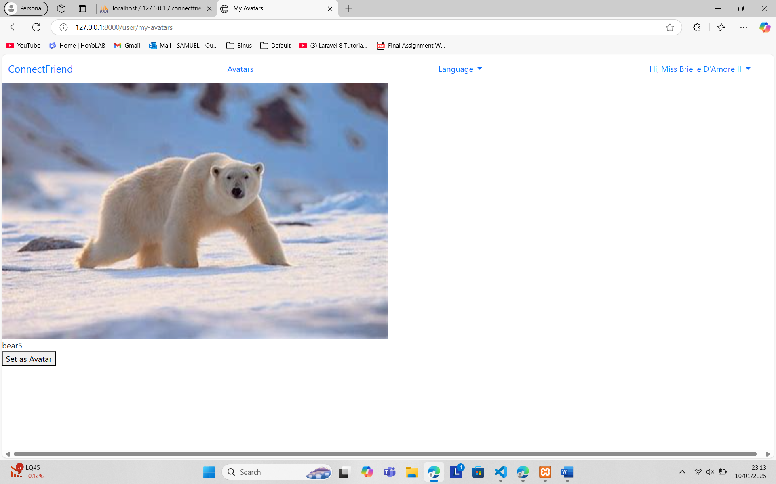

Set as avatar :

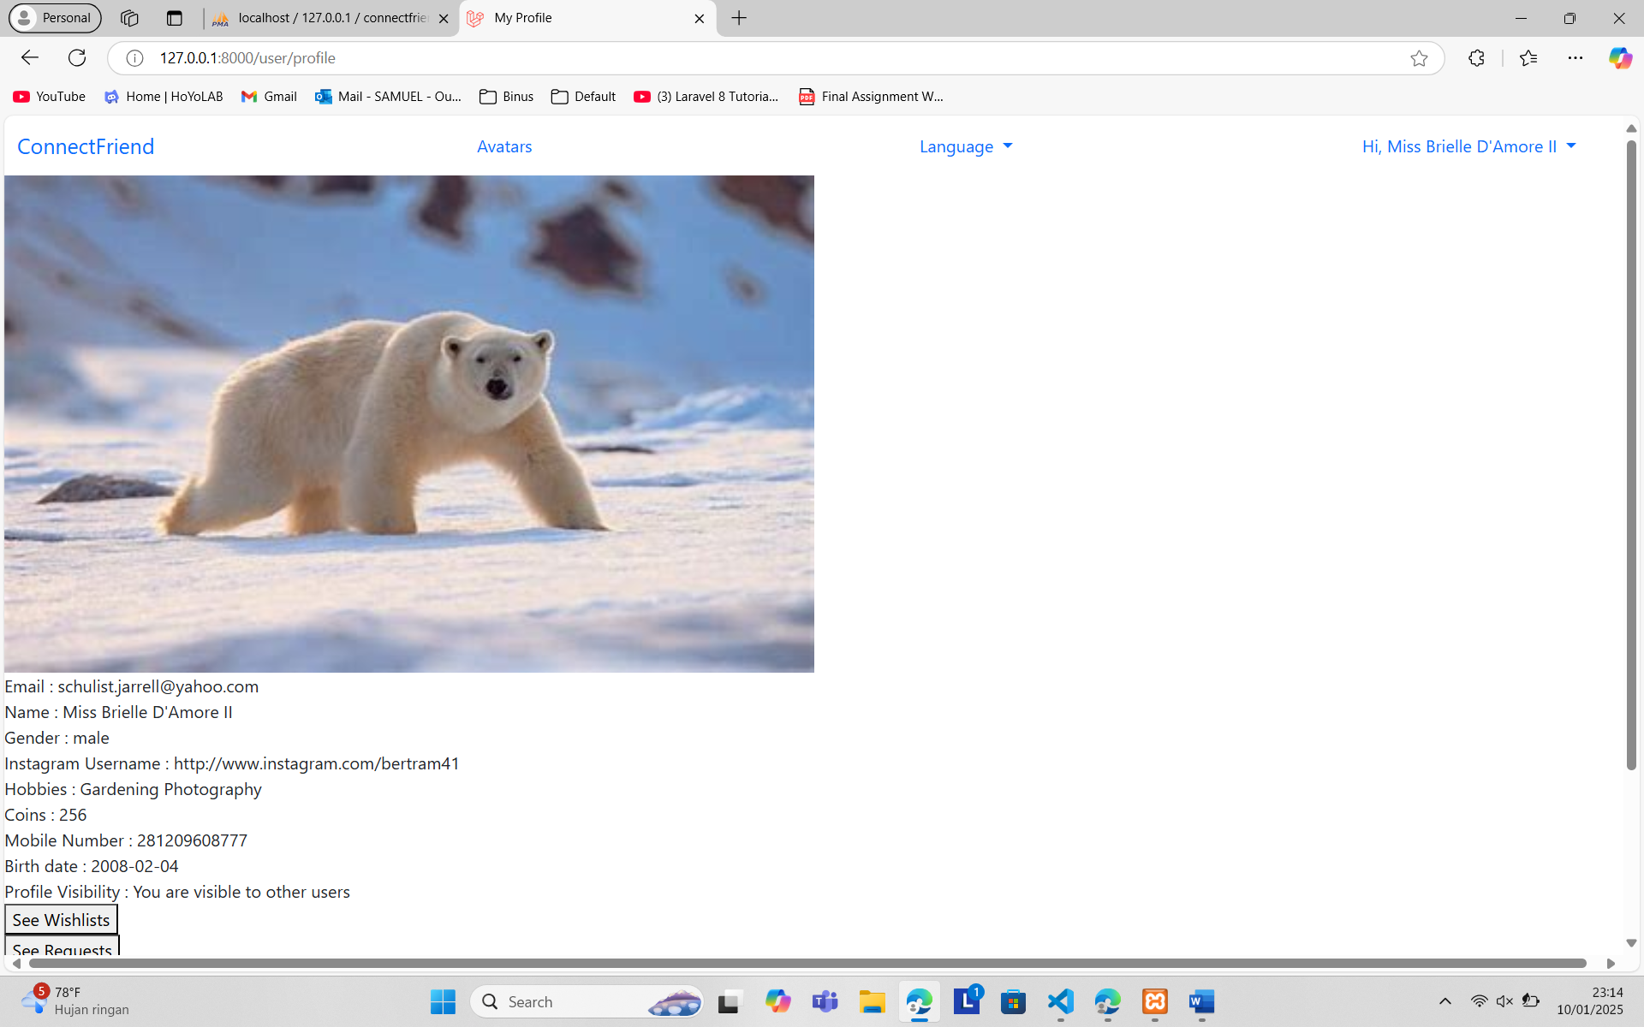

10. Visible Profile

Miss Briell profile (visible) :

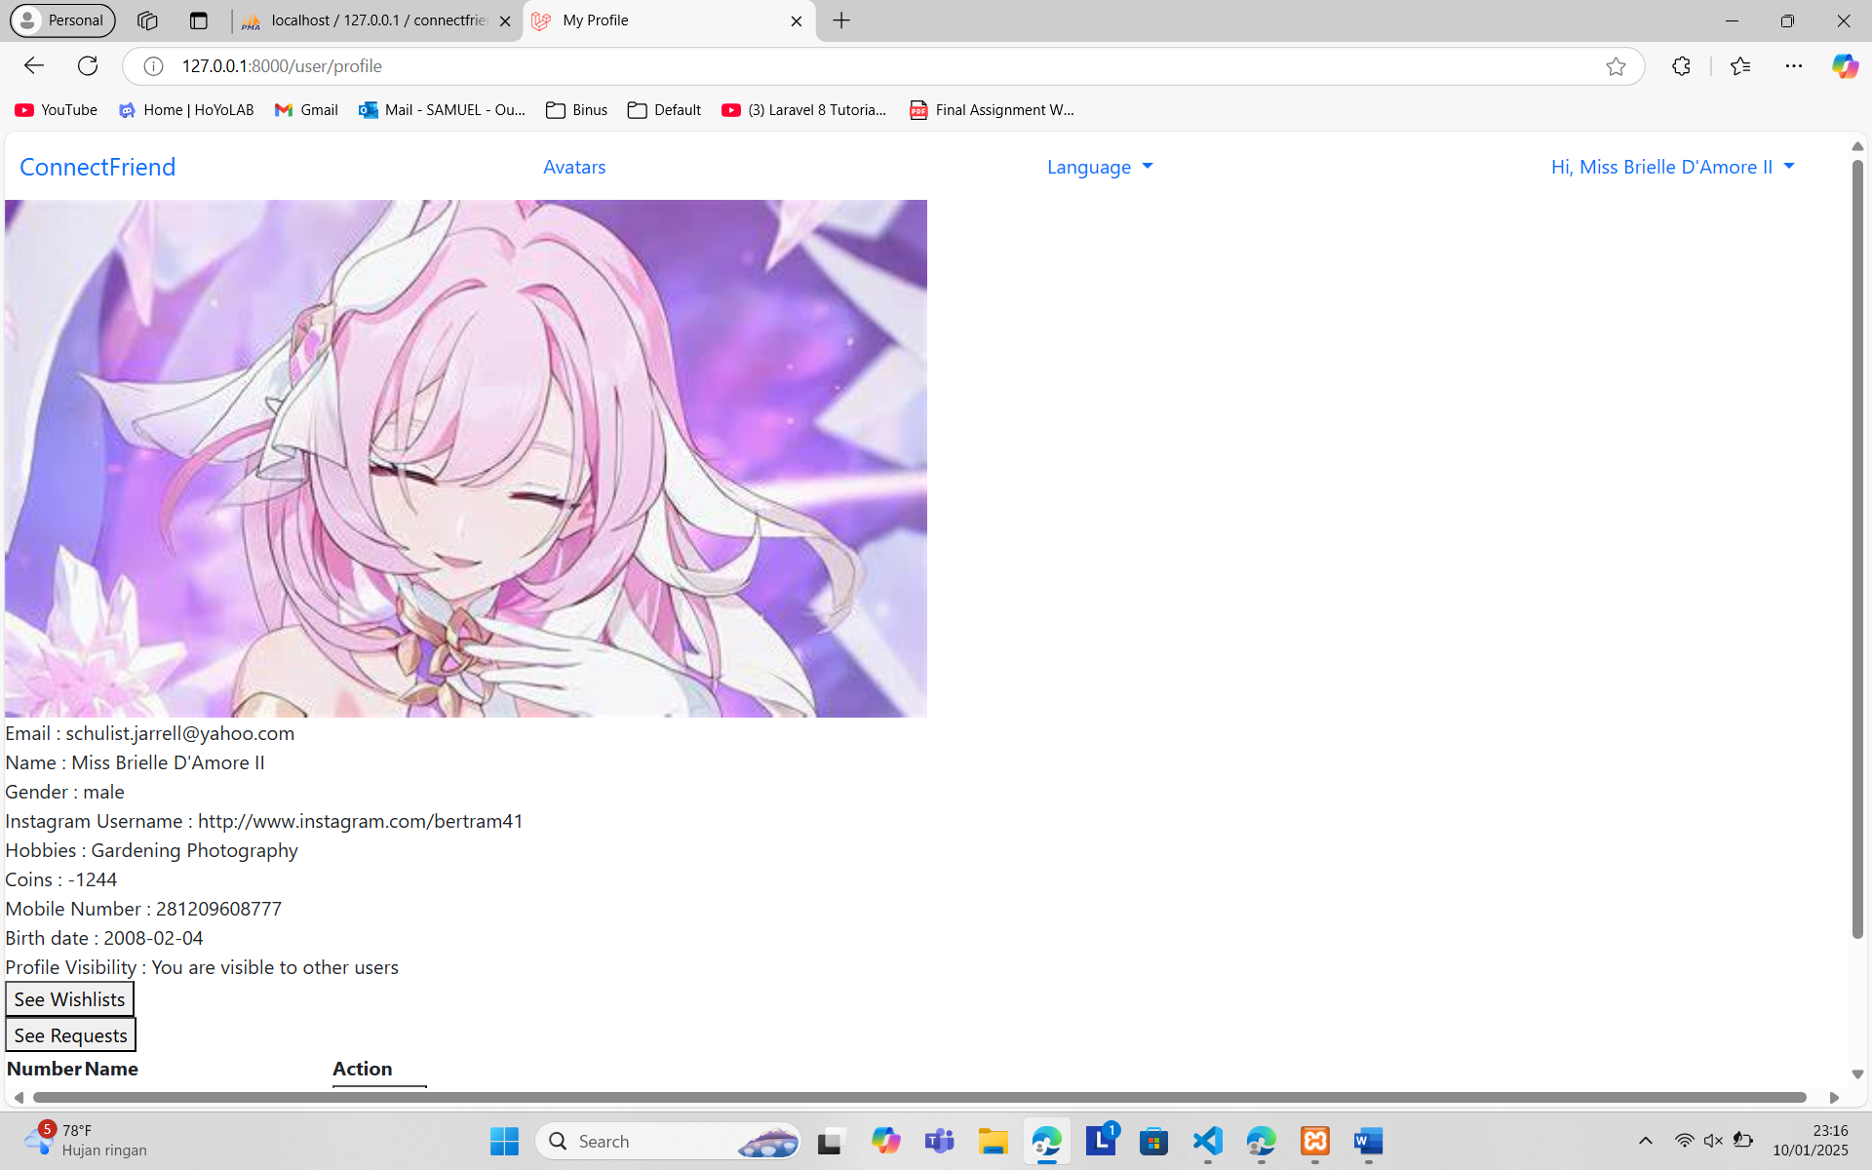

Miss Brielle on home (visible) : 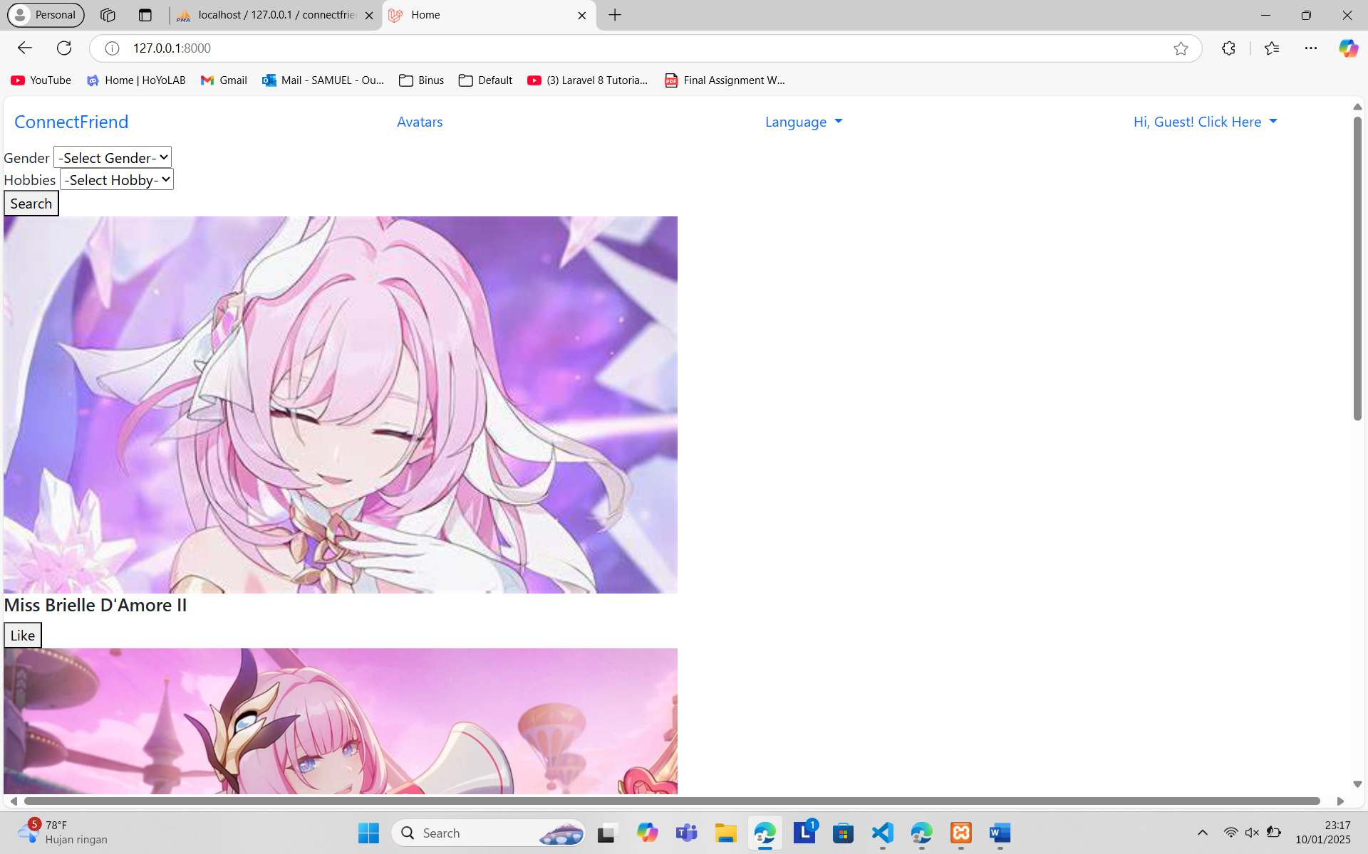

Miss Brielle set invisible :



Miss Brielle profile (invisible) :

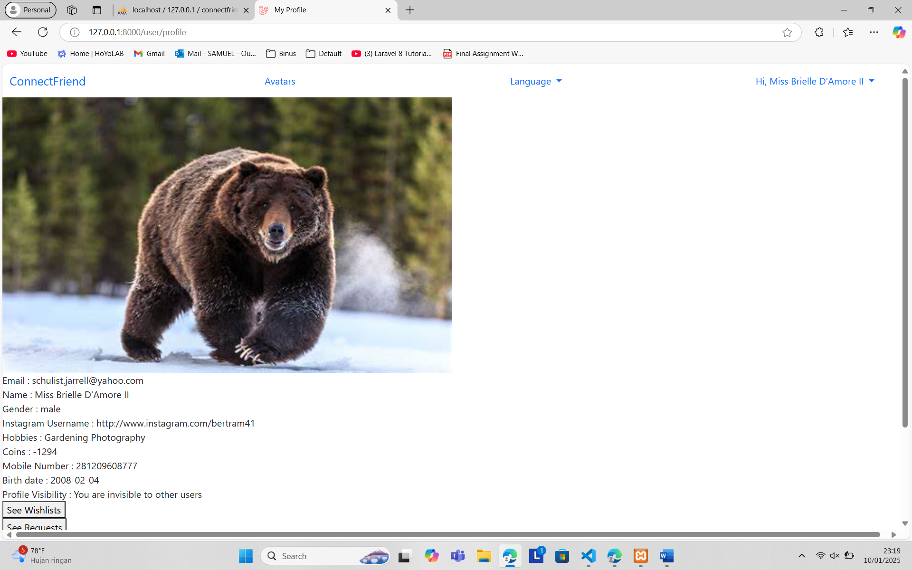

Miss Brielle on home (invisible) :

